URL | Screenshot for 360schooltrips
http://www.travelstart.co.za/blog/101-of-the-best-destinations-in-south-africa/#comment-20605 | 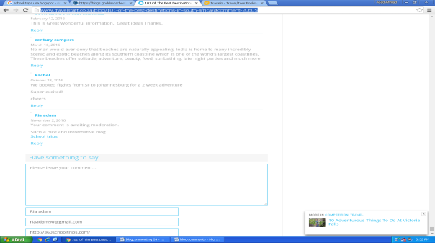
http://www.stonegableblog.com/thankful-place-cards/#comment-298192 | 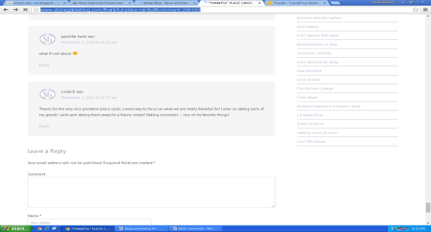
https://www.niagarafallstourism.com/blog/more-improved-streetscape-for-victoria-avenue/ | 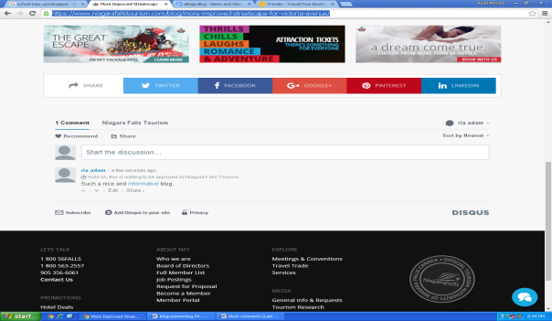
https://blogs.commons.georgetown.edu/studyabroad/2016/10/24/yeah-sure-itll-be-grand/comment-page-1/#comment-23418 | 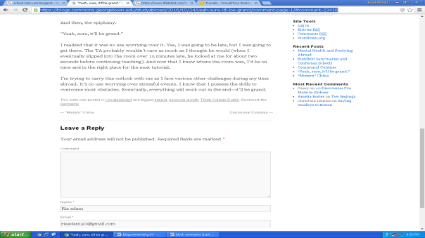
http://www.visitbend.com/blog/2016/10/20/7-fab-ways-date-night-bend-oregon/#comment-179631 | 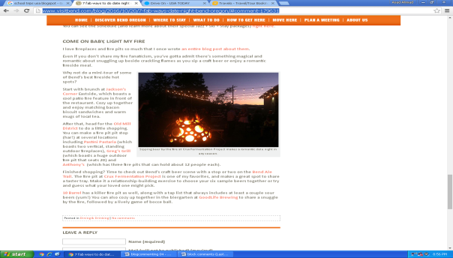
http://usa-roadtrips.blogspot.com/2012/08/the-top-usa-road-trip-travel-tips.html#comment-form | 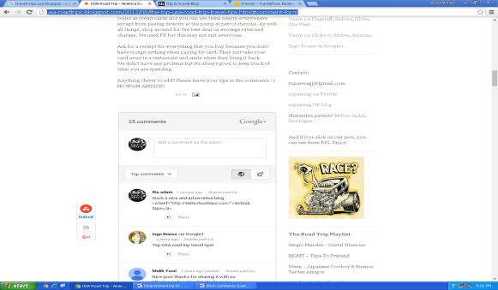
http://www.zencollegelife.com/50-best-north-american-travel-blogs/ | 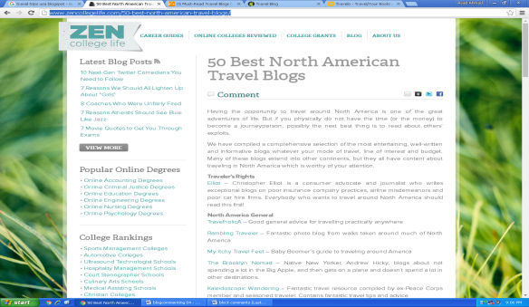
http://www.nomadicmatt.com/travel-blogs/world-best-gay-hotspots/#comment-978409 | 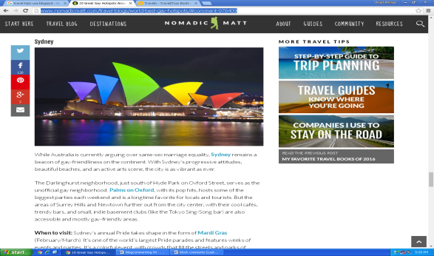
http://www.americabyrail.com/Blog/tabid/78/articleType/ArticleView/articleId/495/4-Scenic-Places-to-visit-on-a-Canadian-Train-Tour-in-the-Fall.aspx | 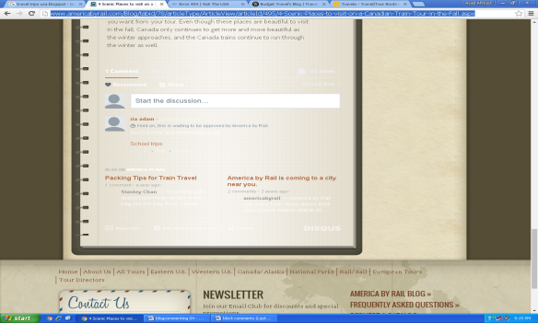
http://www.budgettravel.com/blog/affordable-vacations-in-arkansas-video-series,68736/#commentsdiscussions | 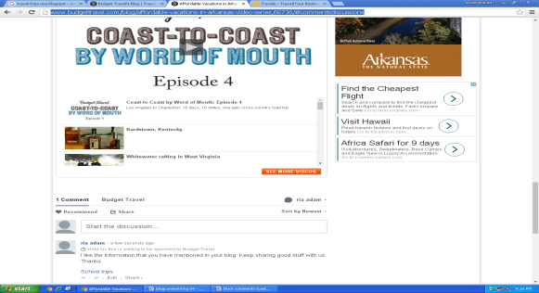
http://www.tourradar.com/blog/quiz-how-do-you-rate-as-a-world-traveller/#comment-91630 | 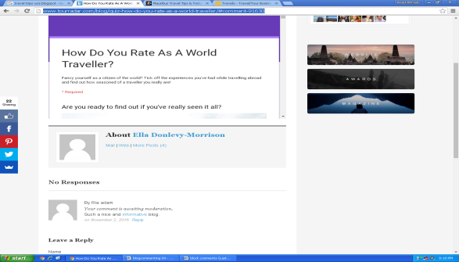
http://ordinarytraveler.com/articles/mauritius-travel-tips-africa | 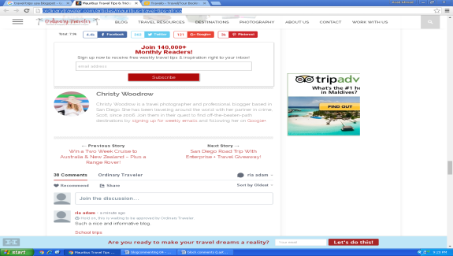
http://www.studentuniverse.com/blog/gap-year/snap-gap/denaes-snap-gap-adventures-portugal#comment-14556 | 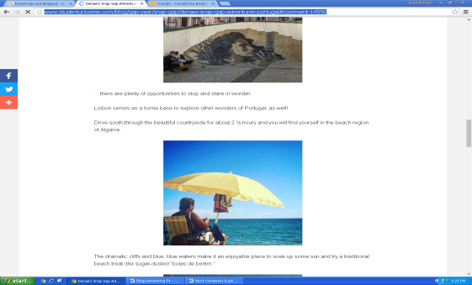
https://www.intrepidtravel.com/adventures/why-everyone-is-talking-about-iceland-right-now/#comment-159196 | 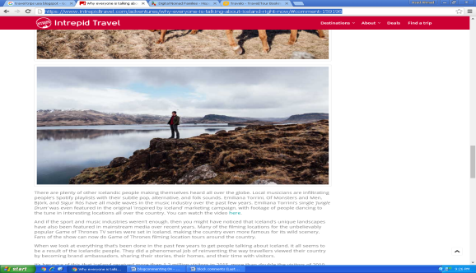
http://www.independenttraveler.com/blog/index.php/2016/11/01/avoiding-identity-theft-a-cautionary-tale-at-35000-feet/#comment-2757800 | 