URL | Screenshot for 360schooltrips
http://blog.tripadvisor.com/2016/11/03/5-european-destinations-visit-winter/#comment-251032 | 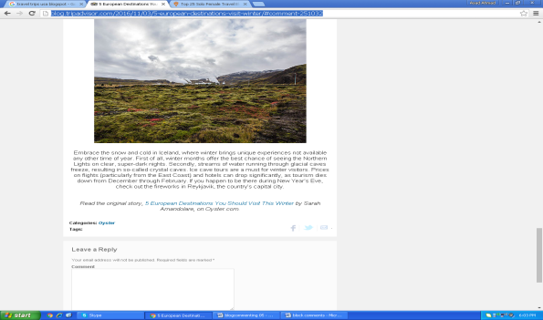
http://solotravelerblog.com/the-florida-keys-sea-history-pies/#disqus_thread | 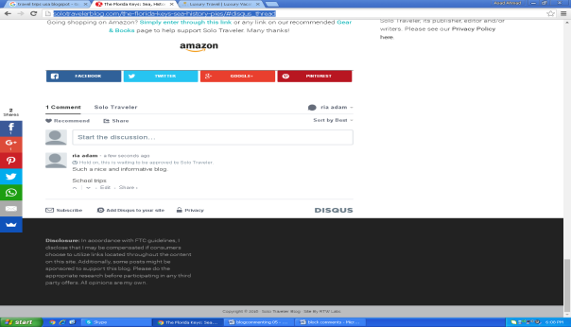
http://www.cheapestdestinationsblog.com/2016/11/02/cargo-ship-karaoke-a-nepalese-funeral-fest-and-eeyou-istchee-internet/#comment-1090267 | 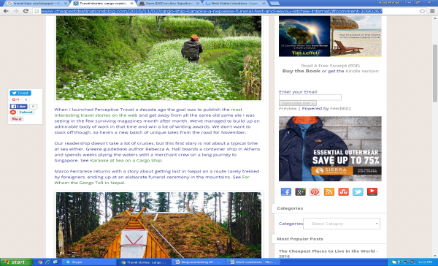
http://merittravel.com/blog/lauras-first-time-in-india/#comment-31813 | 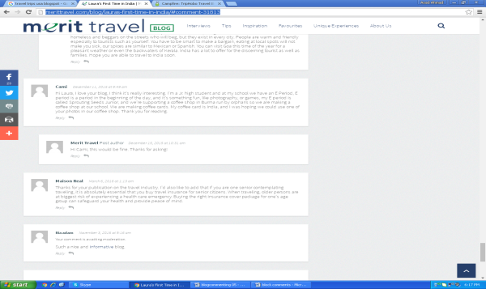
http://unhooknow.blogspot.com/2016/07/please-enjoy-our-award-winning-travel.html#comment-form | 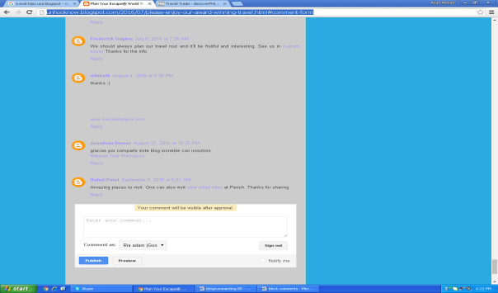
http://blog.insightvacations.com/eight-reasons-need-visit-kakadu/#comment-28834 | 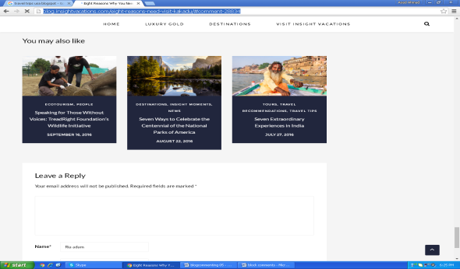
http://www.deep-south-usa.com/blog/726-new-ba-service-launching-between-london-and-new-orleans-next-year | 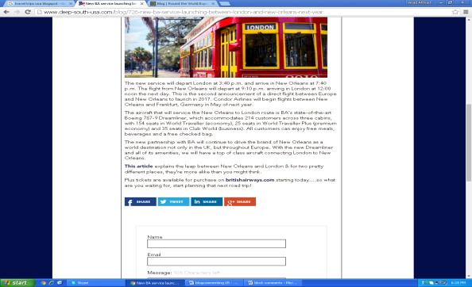
http://www.dangerous-business.com/2012/03/dos-and-donts-on-a-great-american-road-trip/#comment-926058 | 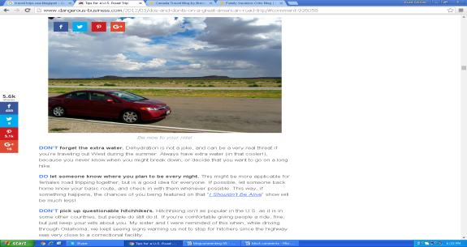
http://www.iwillteachyoutoberich.com/blog/how-to-travel-cheap/#comment-819722 | 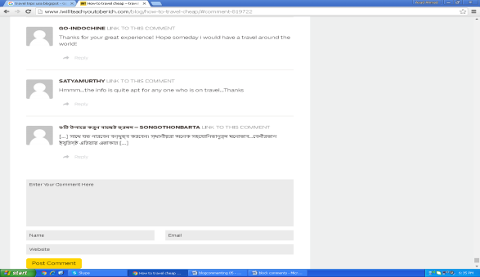
http://www.goabroad.com/blog/2016/07/21/goabroad-writers-academy/#comment-319952 | 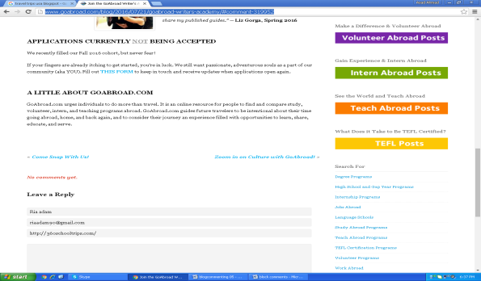
http://livelaughtravel.net/#comment-3570 | 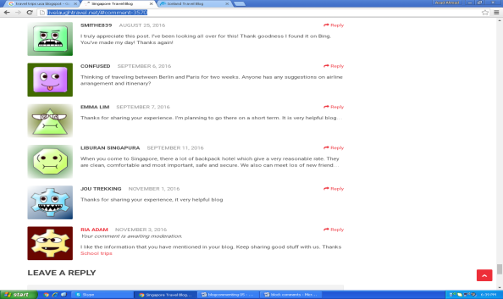
http://www.ytravelblog.com/usa-road-trip-planning/#comment-374002 | 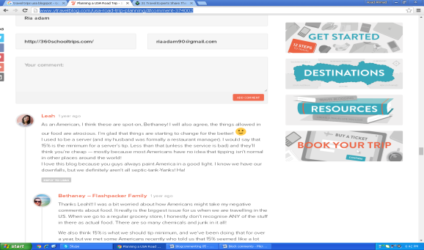
http://blog.ricksteves.com/blog/louvre-on-tour/#comment-84750 | 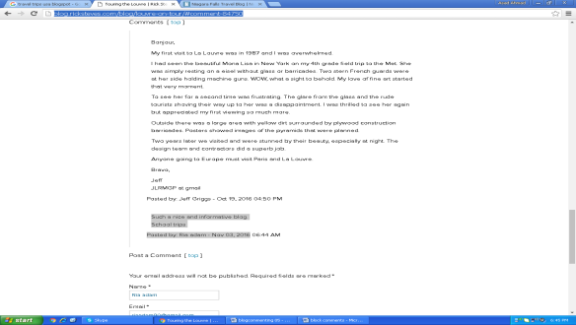
http://www.niagara-usa.com/blog/post/2016/15/10-Things-to-Do-this-Fall-in-Niagara-Falls-USA/149/#comments | 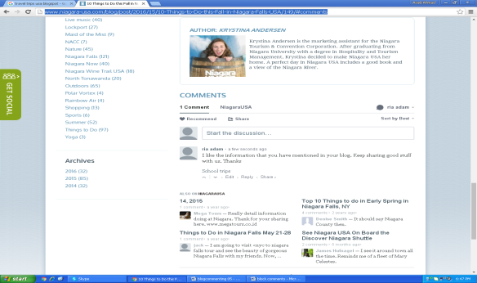
http://www.go2africa.com/africa-travel-blog/12389/how-to-photograph-animals-on-the-move | 