URL | Screenshot for 360vacationcenter
http://nphusa.blogspot.com/2016/10/we-were-able-to-develop-relationships.html#comment-form | 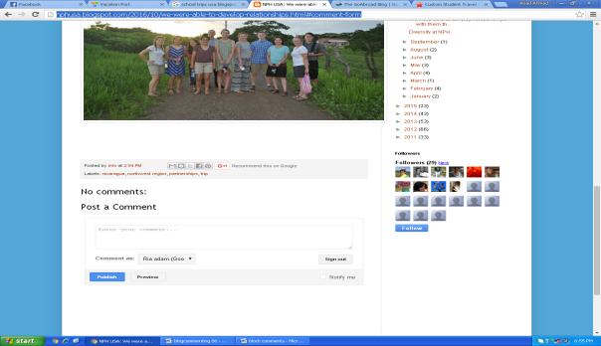
http://www.studentuniverse.com/blog/how-to-save-on-travel/vacation-planning-strategies-save-money#comment-14936 | 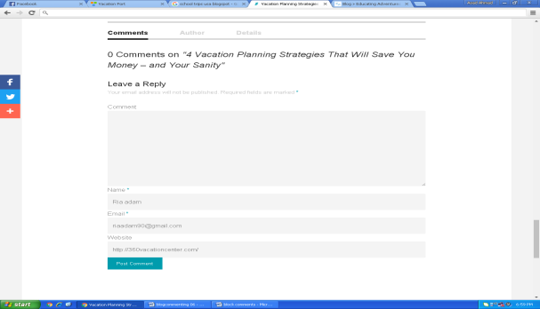
http://www.americabyrail.com/Blog/tabid/78/articleType/ArticleView/articleId/265/America-by-Rail-is-coming-to-a-city-near-you.aspx | 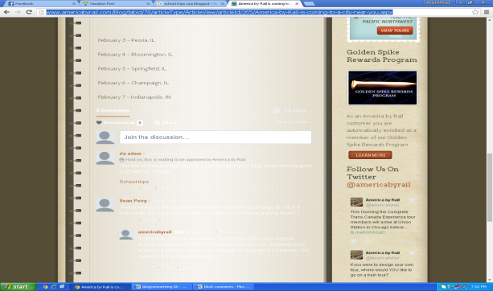
http://thetravelbite.com/destinations/north-america/autumn-travel-picks-peeping-fall-leaves/#comment-241038 | 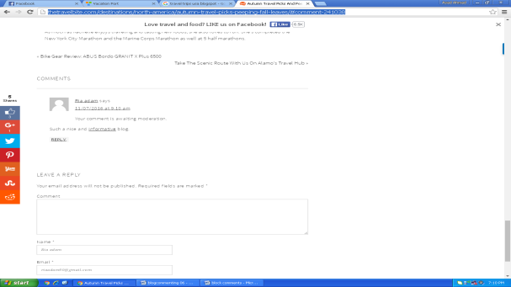
http://www.fly.com/blog/top-flight-deals/97-los-angeles-tofrom-san-francisco-nonstop-rt/#disqus_thread | 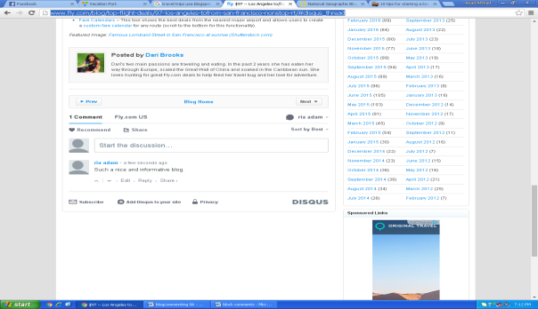
http://youngadventuress.com/2015/02/how-to-start-a-blog.html/comment-page-3#comment-367207 | 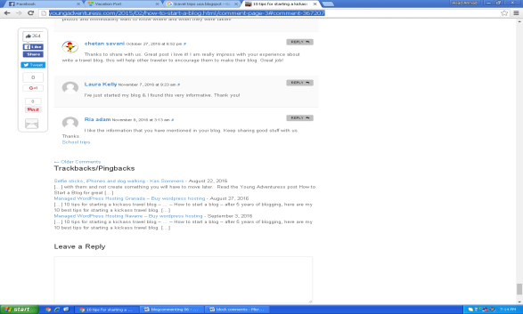
http://twomonkeystravelgroup.com/2016/04/diy-travel-guide-niagara-falls-usa/#comment-93035 | 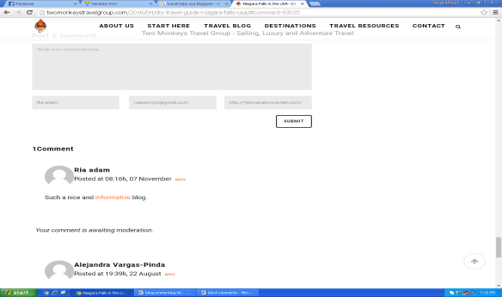
http://cubapeopletopeople.blogspot.com/2016/11/cheap-air-booking-cuba-flights.html#comment-form | 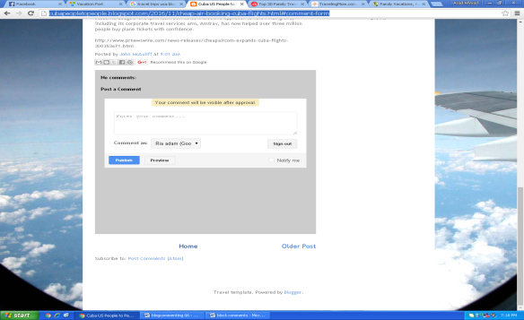
http://redtri.com/top-family-travel-blogs/ | 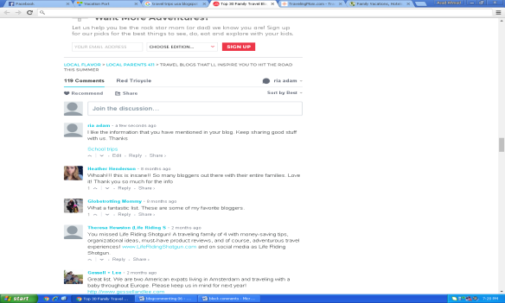
http://www.carolineinthecityblog.com/2016/11/04/lessons-from-my-first-triathlon/#comment-102481 | 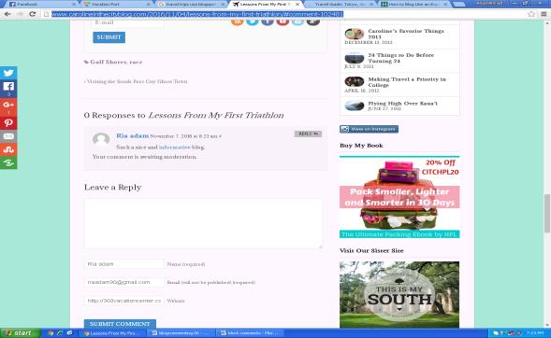
http://thisbeautifuldayblog.com/travel-guide-tokyo-japan/ | 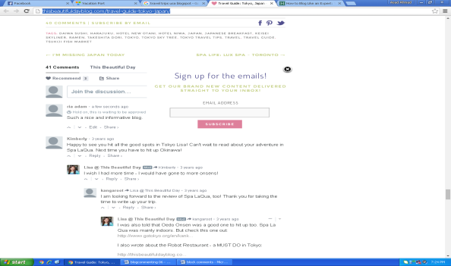
http://heathandalyssa.com/cost-to-travel-america-in-an-rv/ | 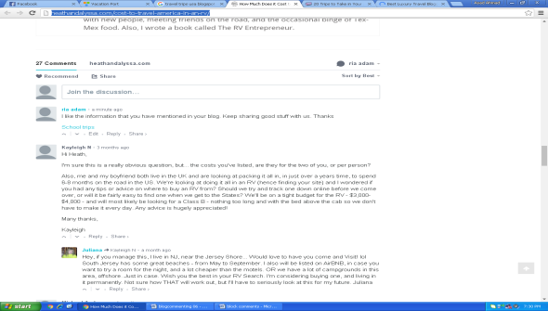
http://theblondeabroad.com/2014/10/12/20-trips-to-take-in-your-20s/#comment-42130 | 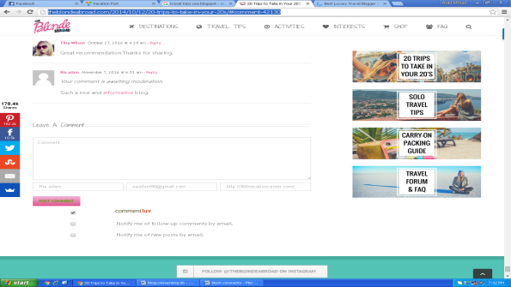
http://www.10best.com/awards/new-media-awards/best-luxury-travel-blogger/ | 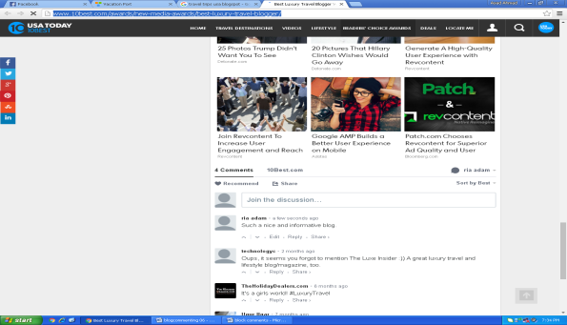
http://twenty-somethingtravel.com/2016/11/working-holiday-taught-financial-responsibility/#comment-2737804 | 