URL | Screenshot for 360schooltrip
http://www.nationsclassroomtours.com/blog/how-to-avoid-losing-kids-on-a-school-trip?success=true | 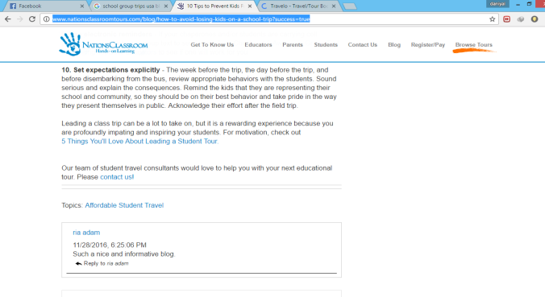
https://www.gooverseas.com/blog/best-high-school-travel-programs | 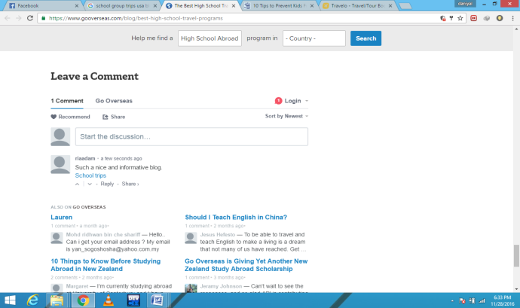
http://www.rayburntours.com/education/blog/education/black-history-month-prompts-us-ask-know-diversity-peoples-history/#comment-1055 | 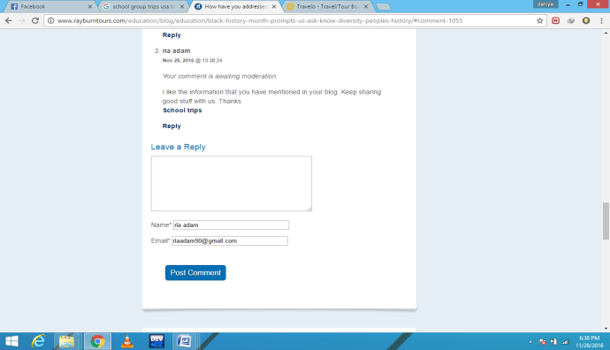
https://www.cheapair.com/blog/travel-tips/how-to-travel-to-cuba-without-a-tour-group-in-8-easy-steps/#comment-707747 | 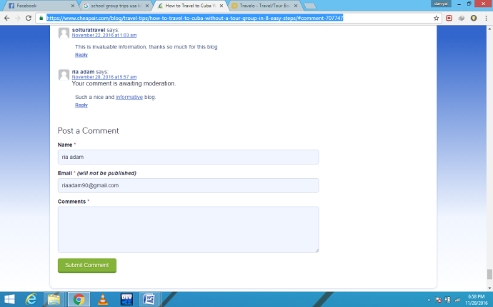
http://mylittlenomads.com/#comment-244591 | 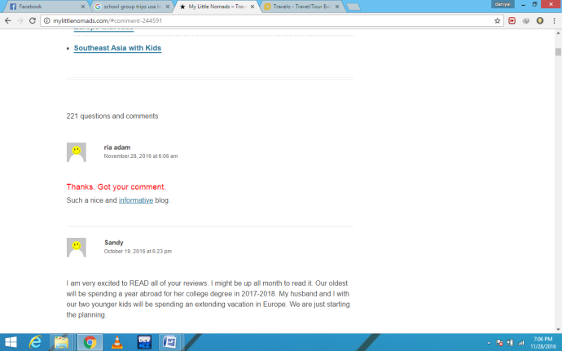
http://blogs.voanews.com/student-union/2012/06/19/why-aren%E2%80%99t-americans-and-international-students-becoming-friends/ | 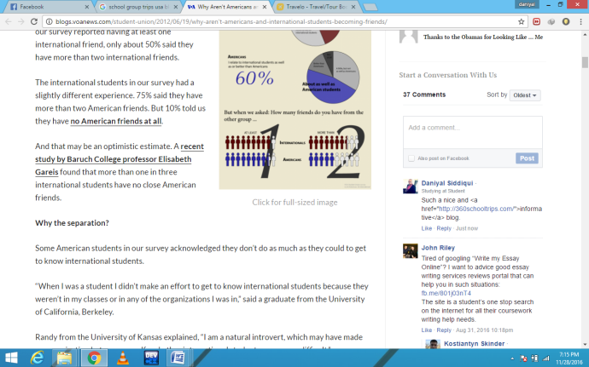
http://www.lindentours.com/blog/2013/07/26/variety/#comment-9078 | 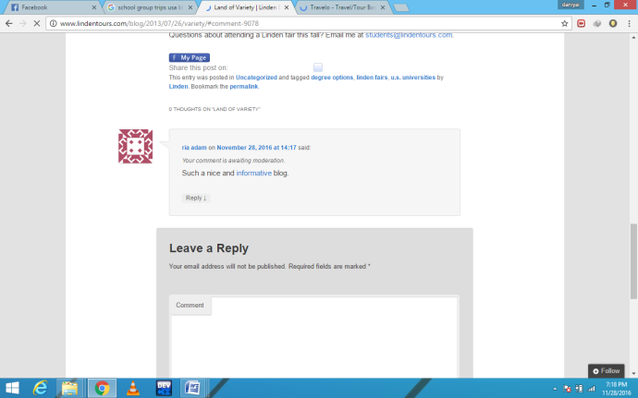
http://www.montereyart.org/blog/when-students-visit-preparing-for-school-group-tours-at-the-museum/ | 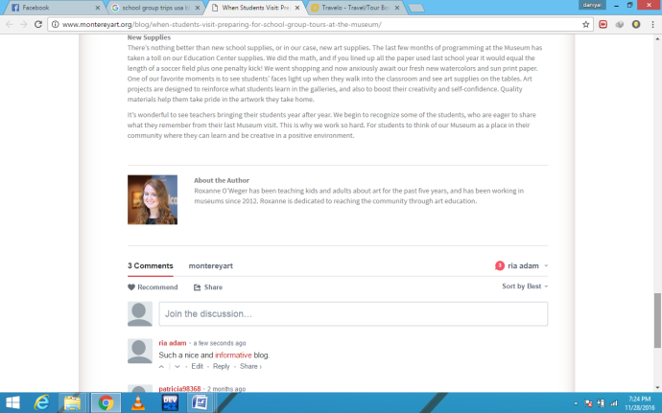
http://www.tripbase.com/blog/whats-best-for-our-kids-11-school-lunches-from-around-the-world/#comment-470417 | 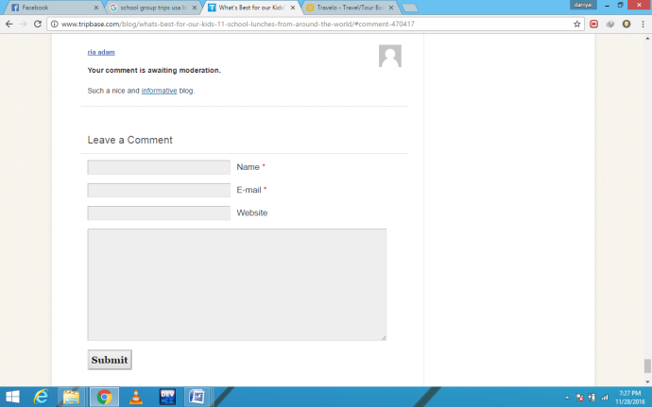
http://blog.flywire.com/2016/06/22/10-things-international-students-should-do-before-starting-college-in-the-u-s/#comment-5175 | 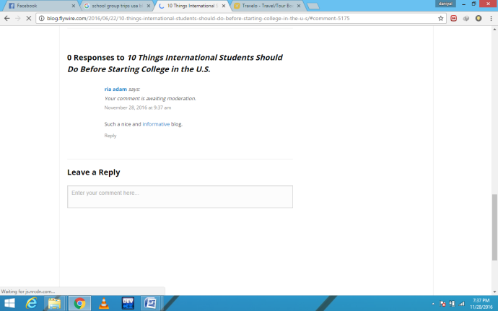
http://protschool.blogspot.com/2011/07/334.html | 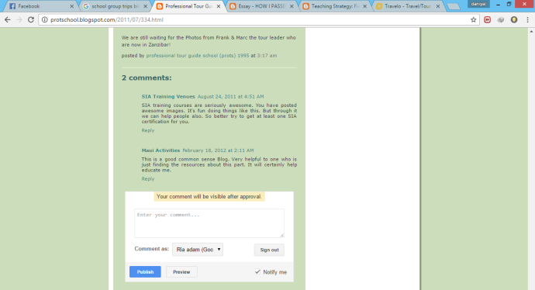
https://happymela.blogspot.com/2012/11/essay-how-i-passed-my-summer-vacation.html?showComment=1480344443030#c664246335621280435 | 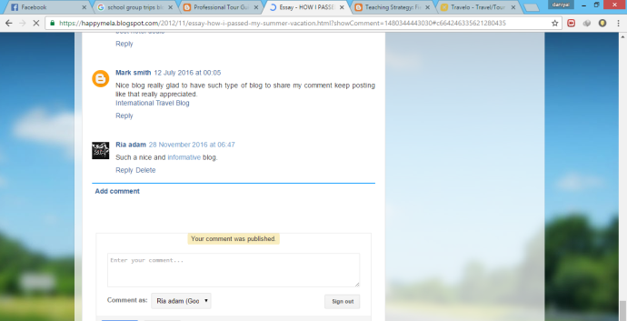
https://eprogressiveportfolio.blogspot.com/2012/06/field-trip-strategy.html?showComment=1480344562236#c1911000220226959948 | 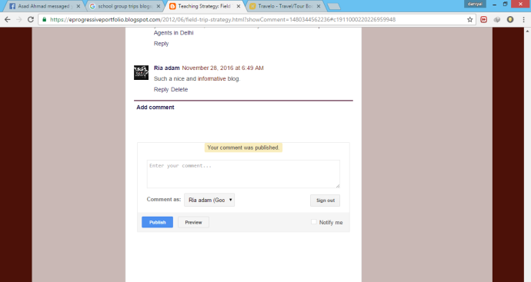
http://googleforeducation.blogspot.com/2015/05/announcing-expeditions-taking-students.html | 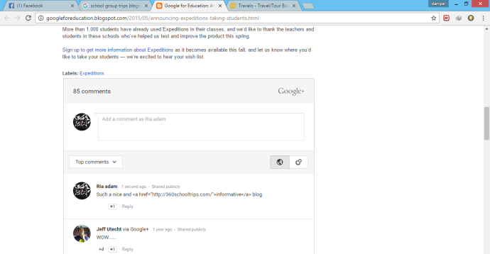
http://tastehistoryculinarytours.blogspot.com/2016/06/the-debutantes-cuisine-culture-career.html#comment-form | 