Directories Submission:
S.no | URL | 360schooltrips Screenshot
01 | http://www.sitepromotiondirectory.com/submit.php | 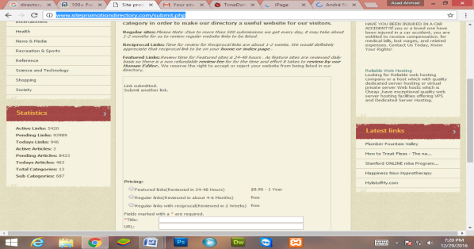
02 | http://www.timedatestamp.com/index.php?adds=67 | 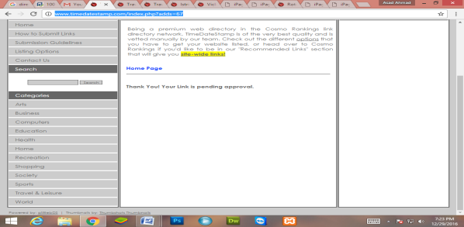
03 | http://www.zendiva.com/index.php?adds=80 | 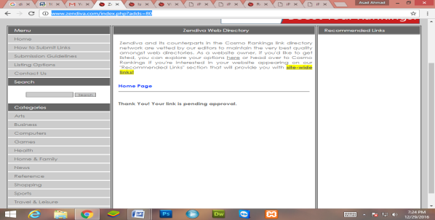
04 | http://www.istriebro.com/index.php?adds=80 | 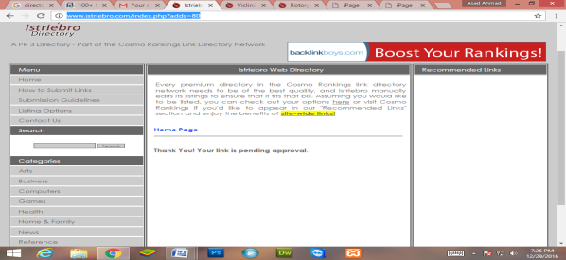
05 | http://www.viclindal.com/index.php?adds=80 | 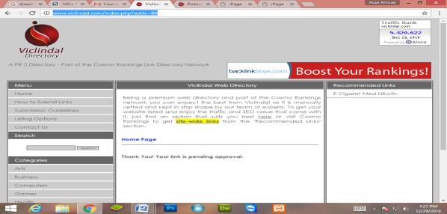
06 | http://www.rotoryswitch.com/index.php?adds=82 | 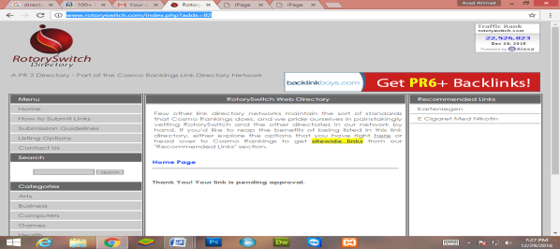
07 | http://www.highrankdirectory.com/submit.php | 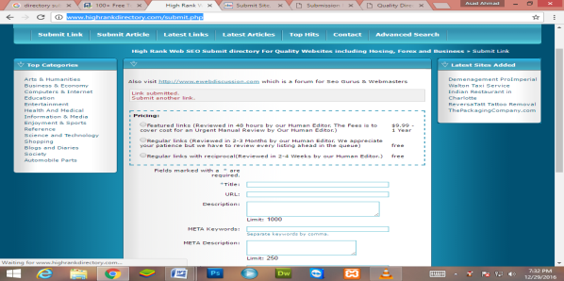
08 | http://www.submissionwebdirectory.com/submit.php | 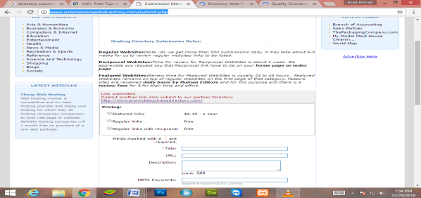
09 | http://www.marketinginternetdirectory.com/submit.php | 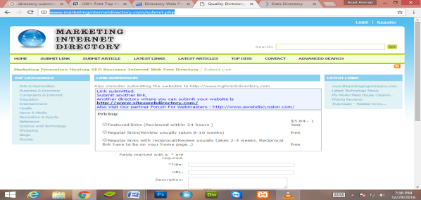
10 | http://www.promotebusinessdirectory.com/submit.php?c=287&LINK_TYPE=2 | 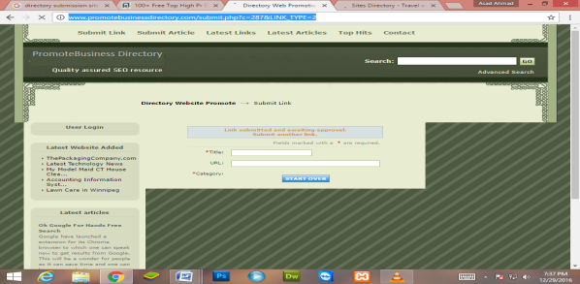
11 | http://www.siteswebdirectory.com/submit.php?c=3483&LINK_TYPE=2 | 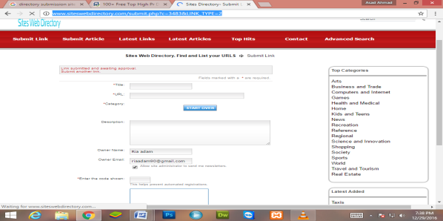
12 | http://www.usalistingdirectory.com/submit.php | 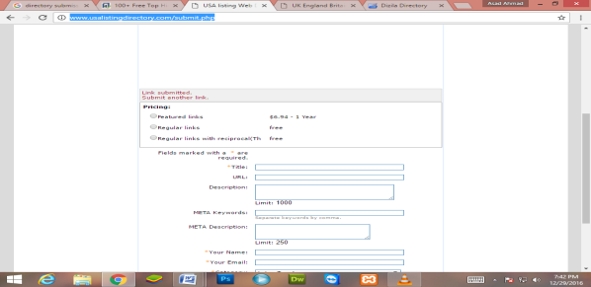
13 | http://www.ukinternetdirectory.net/submit.php | 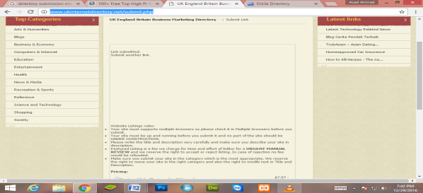
14 | http://www.dizila.com/submit?c=667&LINK_TYPE=1 | 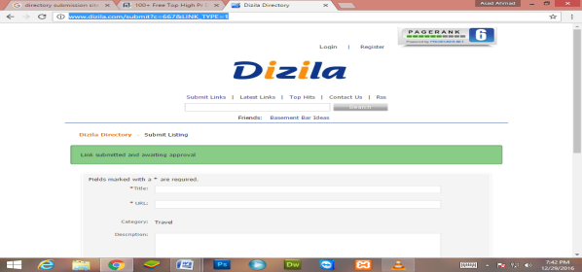
15 | https://www.somuch.com/submit-links/submit-link-result.asp?LinkID=2217362&UserID=934953 | 